UCC MaREI Bios – Dingle Meeting – 22nd April 2022

Prof Jerry Murphy  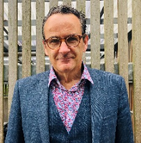 | Director of MaREI & Chair of Civil Engineering in UCC  Professor Jerry Murphy is Director of the SFI MaREI Centre for energy, climate and marine (which has over 250 researchers), Professor of Civil Engineering in University College Cork and leads the Biogas Task of the International Energy Agency Bioenergy (with 19 member countries). He was awarded the Engineers Ireland Excellence Award (2015) for best paper/presentation, The Marine Industry Award for Excellence in Marine Research (2017), an adjunct professorship in University of Southern Queensland (2018), a fellowship of the Irish Academy of Engineers in 2019 and was elected to the international advisory board of DBFZ (German Bioenergy Research Centre) in 2020.  He is a leading authority on circular economy, energy, and environmental systems with more than 180 peer review journal papers, over 12,000 citations and a h-Index of 59. According to Google Scholar he is amongst the top cited academics worldwide in the themes of “bioeconomy,” “biomethane,” and “electro-fuels.” He has supervised 31 postgraduates and currently leads a team of 20 researchers.
Dr Richard O’Shea  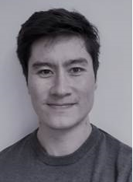 | Lecturer Sustainability in Enterprise UCC  Dr Richard O’Shea is a Lecturer in Sustainability in Enterprise with the School of Engineering in University College Cork (UCC). Richard worked as a Senior Postdoctoral Research, and a Postdoctoral Researcher with the Bioenergy and Biofuels research Group in MaREI with an industrial partner company. His prime area of work was assessing methods to decarbonise a large facility in the food and beverage sector in Ireland. Richard also worked as a design engineer with RPS primarily in the area of HVAC. He obtained his PhD degree in Energy Engineering from UCC in 2018. His research has focused on biomethane production via anaerobic digestion, resource assessments, technoeconomic analysis, optimisation, GIS, and multi criteria decision analysis. This has led to over 30 peer-reviewed journal publications in journals including Applied Energy, Bioresource Technology, and Renewable Energy.

Dr David Wall | Lecturer School of Engineering and Architecture UCC  Dr David Wall is a lecturer in the School of Engineering and Architecture in UCC and a Funded Investigator in the SFI MaREI Centre under the research area “Advanced Fuels and the Circular Economy”. David has previously attained grant funding for the SFI EFACE project (electrofuels in a circular economy) and SEAI EcoAD project (Developing Economic solutions for On-Farm anaerobic digestion in Ireland). He has published ca. 35 peer reviewed journal papers on bioenergy systems. David is also a member of the IEA Bioenergy Task 37 and has written three technical reports on the future of renewable gas in the wider energy system.
Dónal O’Ceileachair  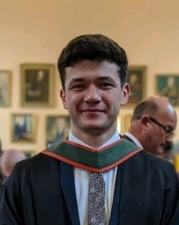 | PhD Student MaREI UCC  Dónal is a PhD student researching anaerobic digestion as part of UCC’s SFI MaREI Bioenergy & Biofuels research group. Before becoming a PhD researcher with MaREI in April 2020, Dónal worked with an engineering consultancy on the Dingle Peninsula Anaerobic Digestion Feasibility Study. Dónal is currently researching as part of a team working on the project “Developing Economic solutions for on-farm Anaerobic Digestion technologies under Irish conditions (EcoAD)”. Dónal’s work focuses on optimising the logistics of on-farm AD in Ireland. Dónal’s research also includes studying the effects of seasonal slurry availability, and also of seasonal gas demand, on the operations of an on-farm AD plant.
Xue Ning | PhD Student MaREI UCC  Xue is working on economically viable pathways for biomethane based on novel and existing digestion systems. Her current work focuses on integration of microbial electrolysis cell with anaerobic digestion for advanced biofuels/chemicals production within the MaREI Bioenergy & CEEES Research group. Xue’s current research is funded by the National Energy Research Development and Demonstration (RD&D) Funding Programme 2019 - Sustainable Energy Authority of Ireland.
Jorge Diaz Huerta  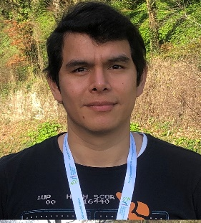 | PhD Student MaREI UCC  PhD student researching the techno-economic considerations with respect to on-farm anaerobic digestions and the need for a biorefinery approach as part of UCC’s Marei SEAI EcoAD research group. The main subject of the EcoAD WP4 from Jorge is related to Techno-economic analysis of pathways for On-farm Anaerobic Digestion in Ireland, to optimize the process and compare cost of the different technologies used in the production of Biogas through Anaerobic Digestion.

